Assignment 2

Must have zero steady state error 🡪 PI/PID? can eliminate steady-state errors resulting from a disturbance (PID best? See C8 slide 74 maximum closed loop bandwidth and no steady state error), maar maxime zegt dat hij blijkbaar in de les heeft gezegd dat we PI moeten gebruiken?

1e ander verslag:   
“The two controllers we can use to realise a zero steady state error are the PI and the PID controller (or in most cases the PD part is replaced by a lead controller). Since we already have a significant amount of phase margin, we don’t think it’s necessary to use a lead controller so we choose for a basic PI-controller (Proportional-Integrator-controller).”

<-> feedforward can only eliminate steady-state errors resulting from the reference signal

We want fast respons 🡪 large bandwidth 🡪 PI in combination with lead?

But C8 slide 82 sampling frequency at least 10-20 times larger then bandwidth

Lowest possible influence of high freq noise 🡪 Lower bandwidth?

Choice PI then?

(following for discrete time)

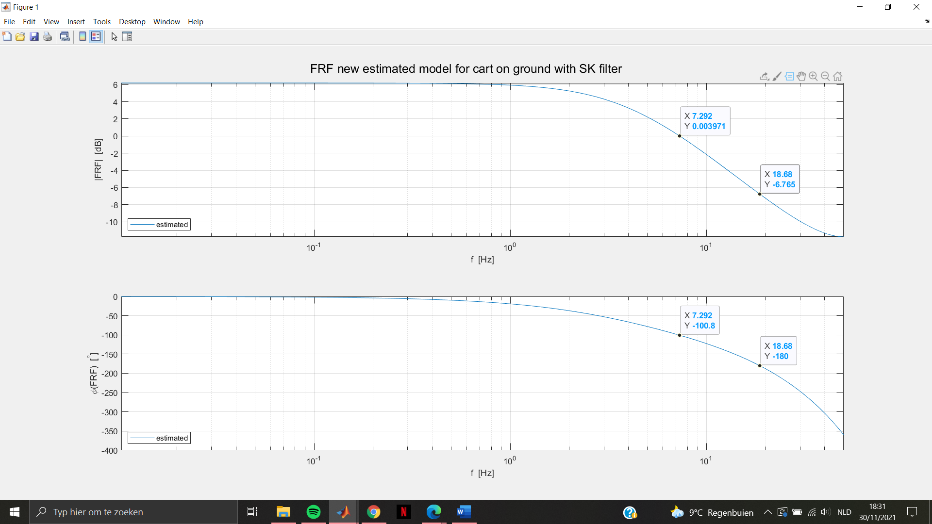

Choose PM = 45°? (C7: Slide 17 PM = 40° … 50° design value)

Choose GM = 2 = 6.02 dB

Choose Dphi_PI = 10°…15° = allowed phase lag of the PI controller at the crossover frequency

The smaller this margin, the bigger T_i -> better to prevent phase lag problems ( took 12°)

Design method followed from exercise session